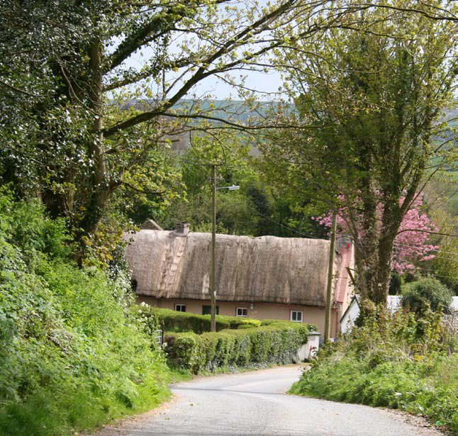
Ten Step Guide to Researching your
Donegal Ancestry
O’Donnell, Stewart, Sweeny, Alexander, Gallagher, Lowry, O’Doherty, Gourly,
Boyd, Tinney, Colhoun, Peoples, Hamilton, Lynch, McAdoo, Bradley, Curran,
Sweeny, McDaid, McClintock, Porter, Wilson, McCormick , Crawford, Bryce
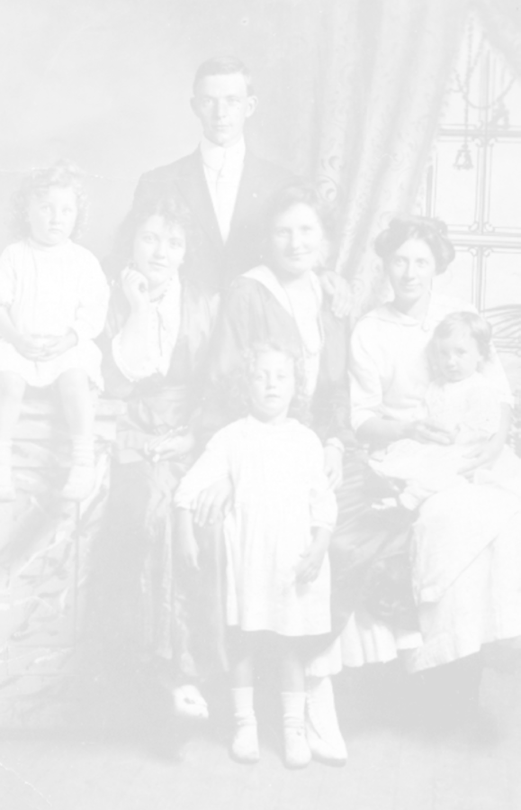
Step 1: The Griffiths Valuation 8
28
29
30
31
Triangulating
Hints and Tips
Useful Addresses
Map of Donegal
Step 2: Maps of parishes and their townlands 11
Step 3: Check the 1901 and 1911 censuses 12
Step 4: The Tithe Applotment Books 16
Step 5: Church Records of Births, Marriages and Deaths 18
Step 6: Civil Records of Births, Marriages and Deaths 20
Step 7: Griffiths Valuation Revision Books 23
Step 8: House and Field Books 25
Step 9: Wills 26
Step 10: Old Age Pension/Census Returns 27
3
Contents
Using the Guide
Using the guide
3
The purpose of this booklet is to provide a simple step by step
guide for those who wish to research their ancestry in Donegal in
the Nineteenth and early Twentieth Centuries. It concentrates on
sources available both locally and on the internet, with some
reference to sources available nationally. It makes significant use
of the internet so, because web page addresses sometimes change,
it may occasionally be necessary to go to the website’s home page
and find a particular page. The main website for any page is the
first group of letters after http:// and frequently ends with .com, .org,
.ie or .uk. Where Tinyurls have been used to shorten overly long
web addresses, the name of the website will not be given and it may
be necessary to put some key words into the Google search engine
in order to find the site.

The information contained herein is equally valid and applicable to
all creeds and denominations but only the three main churches
are covered specifically, viz: Catholic, Church of Ireland and
Presbyterian.
The guide assumes that you have already talked to the more
senior members of your family, who will have oral or indeed
written information, and that this has concentrated your research
in Donegal.
The guide is laid out in the order you might consider conducting
the research, which in turn is governed by the availability of
sources. However, your research will also be governed by whether
you are in Donegal and can easily visit local repositories or
whether you will be dependant on the internet, writing to and
emailing local and national archives in Belfast and Dublin and
visiting your own local Family History Centre. Much of the research
described here can now be done on the internet.

Much of what is contained in this guide is equally relevant to any other
county in Ireland.
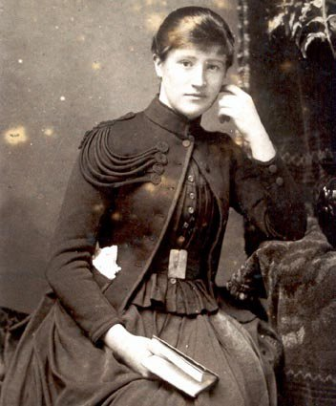
This is a basic guide to Family History research in Donegal. It is what
4
you might realistically expect to achieve during a week’s visit to the
county, if you make preparations in advance of your visit. It does NOT
cover the much more laborious, time consuming and difficult business
of researching the many documents available in the national archives
in Belfast and Dublin.
Family History Centres (FHCs) are Mormon (Church of Latter Day
Saints or LDS) run local repositories of records. They are an essential
resource both for people from Donegal and also for those living
elsewhere. The Mormons have millions of records on microfilm, which
are free but for pastage. For people in Donegal, the nearest
Family History Centre is the one at the Mormon Church on the
Racecourse Road in Derry City. The telephone number is 028 7135
0179 (0044 7135 0179 from outside the United Kingdom) and you
should ring in advance to book the use of the microfilm reader. The
centre is open from 10am to 1pm, Monday, Wednesday and Friday
and 7pm to 9pm on Thursday. It has a huge stock of films and they are
all are free to view.
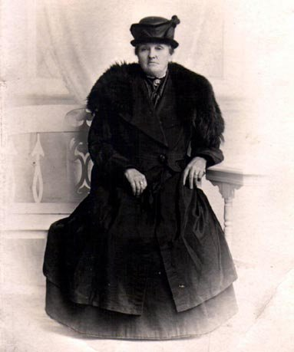
These films include:
Index
1864 - 1958
1845/64 - 1958
1864 - 1958
17th century
1766
1796
Records
1864 - 1881
1845 - 1870
1864 - 1870
1828 - 1834
1848 - 1858
1841 and 1851
1901
5
Civil Births
Civil Marriages
Civil Deaths
Index to Raphoe Diocesan
marriages
Muster Rolls
Protestant Householders Index
Flax Growers Lists
Tithe Applotment Books
Griffiths Primary Valuation
OAP/ Census Records
1901 Census
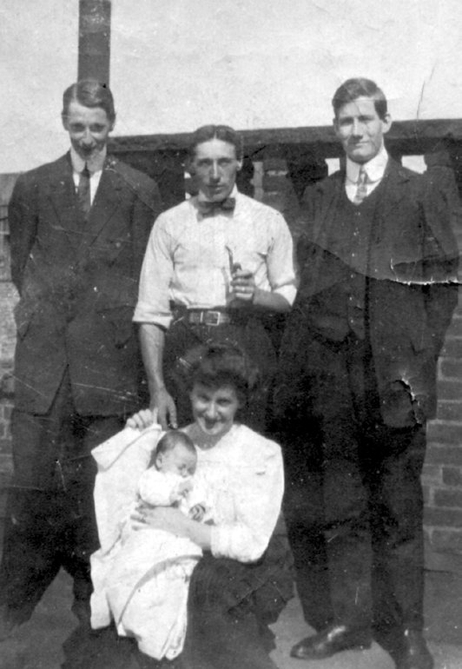
Many more can be ordered from Salt Lake City for a few pounds.
You will find your nearest Family History Centre at: http://tinyurl.com/4po5

6
To conduct successful research in Ireland, you really need to know
your ancestor’s name, an approximate date of emigration, and
preferably the townland or at least the parish where she or he lived.
Earlier than the middle of the Nineteenth century and it becomes
considerably more difficult because the main record, the Griffiths
Valuation, was only produced in the 1850s.
A townland is the smallest administrative unit in Ireland; it is not a
town (urban area) though it may contain one or more clusters of
houses, sometimes known as clachans; it is still the basis of
addresses in the Republic of Ireland.
If you do not know the townland, you can try to “triangulate” using
two or three ancestors’ names (see page 28).
Remember, many people in Nineteenth century Donegal could
neither read nor write, so there was no “correct” spelling of a name.
A McClements could just as easily be a McLamont or even a
Clammond. It depended on how the clergyman, or the clerk, decided
to write down the name. So, search for all permutations of a name.
Finally, you should try to do as much research as possible on the
internet, not just into your particular family, but also into the
resources which are available, where you will find them and what
they will contain. There are many sites relevant to Donegal which
you can use but the most comprehensive is the website created
by Lindel Buckley of New Zealand. Packed full of original data, it is
growing on a daily basis. Check it out at:
http://freepages.genealogy.rootsweb.com/~donegal/
(or simply search for “Lindel Genealogy Donegal” using Google.)

This genealogy booklet is on the front page of Lindel’s
website and the blue links are live = click and go.
http://tinyurl.com/ckwzppd

It can also be found at Bob’s excellent Donegal website:
7
http://tinyurl.com/5h3k83

Step 1: The Griffiths (Primary) Valuation online index
8

This was a land survey published in Donegal in the mid 1850s and
is often referred to as a census substitute. The reason we need
a census substitute is that almost ALL of the censuses from the
Nineteenth century were destroyed, either deliberately
during World War One to create paper, or accidentally in the fire
at the Four Courts in Dublin during the Civil War in Ireland in 1922.

The Griffiths Valuation only gives the Head of Household in each
townland and not the spouse, children or assorted grannies, aunts,
uncles, cousins and friends who may have lived there. Not much,
but the best we have. An index of the names and townlands in this
survey is online at several sites so, in seconds, you can begin to see
if you have ancestors in Donegal.
The full Griffiths Valuation can be viewed online at:
http://www.askaboutireland.ie/griffith-valuation/
This web site has not only all the details of each household but also maps showing the locations of each house.

It is essential to have the correct spelling of both the surnames and the
townlands in order to search the Griffiths Valuation at the main website
above. Fortunately, there is another website which lists everyone in
the Griffiths Valuation by Surname and by Parish so you can find the
correct spelling and also do faster searches using the indexes there:
http://tinyurl.com/44brbwh

It is also possible to view microfilms of the full Griffiths Valuation at
Letterkenny Central Library, but you will need to book a microfilm
reader. Telephone: (00353) 74 9124950.

By combining the Griffiths Valuation maps with modern
Ordnance Survey maps, it is possible to drive straight to
the place where your ancestors lived in the Ninettenth
Century.

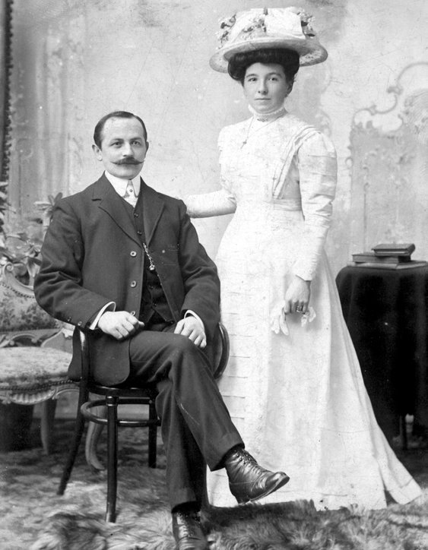
The full Griffiths Valuation will tell you how much land, if any, the Head
of Household leased, rented or owned, the value of any land or
buildings, and therefore give some indication of how wealthy she or he
may have been (see page 10 for an example).
9
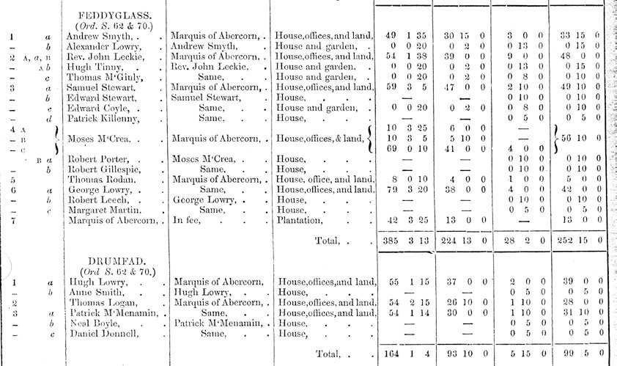
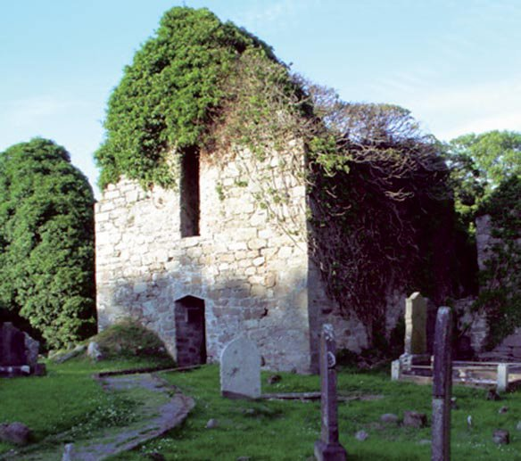
11
Step 2: Online Maps of Donegal parishes and their
townlands
The main benefit of these maps is that, when used in conjunction with
the online Griffiths Valuation index, you should be able to identify the
townlands adjacent to or near to the one where you think your
ancestors originated. This is important because your ancestors
might have moved back and forth between nearby townlands as they
changed jobs, or married people who came from nearby townlands.
So, the people in the townland next door, or a few townlands away,
could well be your family or relatives of your family by marriage.
Bob Hilchey has produced some excellent online maps of townlands
and parishes in Donegal and they can be found at:
http://tinyurl.com/6cc52j

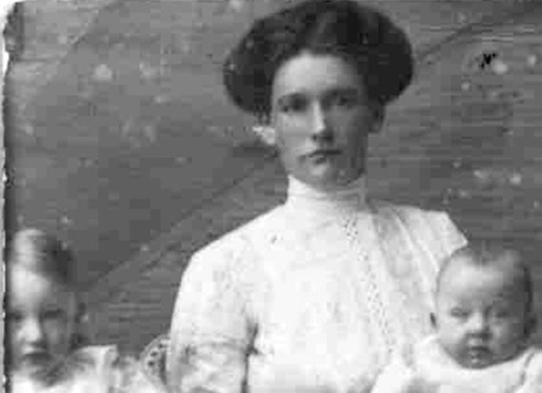
Step 3: The 1901 and 1911 censuses
Useful for finding ancestors who did not leave Donegal in the
Nineteenth century, or who left the area in the 20th century or for
finding the descendants of siblings and other relations of those left
behind when your folks did emigrate. They would be your “cousins”.
The 1901 Census will give more data than almost any other source.
As well as the name of the Head of Household, it will give other family
members, ages, where born, religion, marital status, literacy and
county or country of birth.
The 1911 census has even more data including how long a couple had
been married, how many children a woman had and how many of them
were still alive. Remember to tick the box, “Show all information”.
There are two pages of particular interest in each census. The top
sheet, called Form B1, gives details of who lived in every house in the
townland, who owned the houses and what sort of houses they were.
Form A gives details of the inhabitants of each house.
12
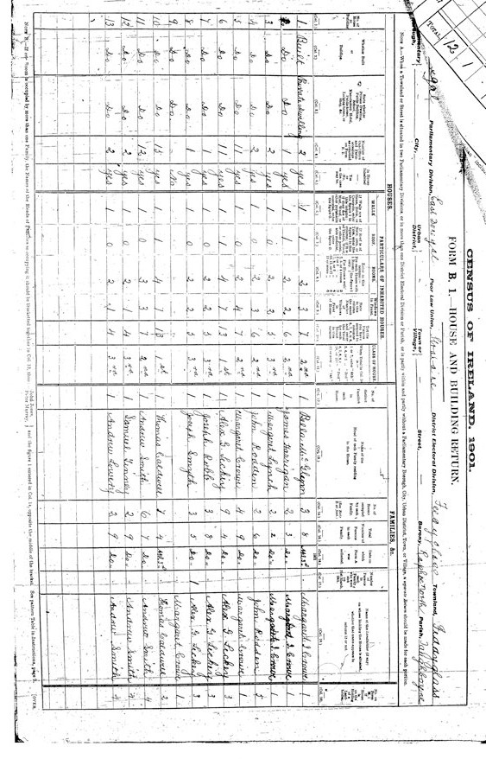
13
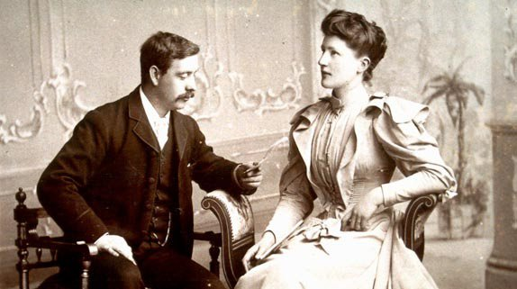
Do not expect all details in these censuses to be totally accurate.

Letterkenny Central Library has both of these censuses on
microfilm – book up the reader as there is only one - Tel No is 00353
74 9124950 or 00353 74 9124950 from outside the Republic of
Ireland.
The 1911 census is also now available online in full at:
http://www.census.nationalarchives.ie/search/

This database, like the one for the Griffiths Valuation, requires
that you always enter the correct spelling for both surnames and
townlands. This means trying various spellings for each or you
can also try entering another townland close by that is easier to spell,
finding the DED and then using that along with the surname to
find the correct spelling of the townland, which may actually change
between one census and the next.

The house numbers have no significance and will also change.

And do not expect people to be honest about their ages! The
1911 Census is usually more accurate as the Old Age Pension
was introduced in 1909 and people had to be 70 so there was an
incentive to be honest about your age!

14
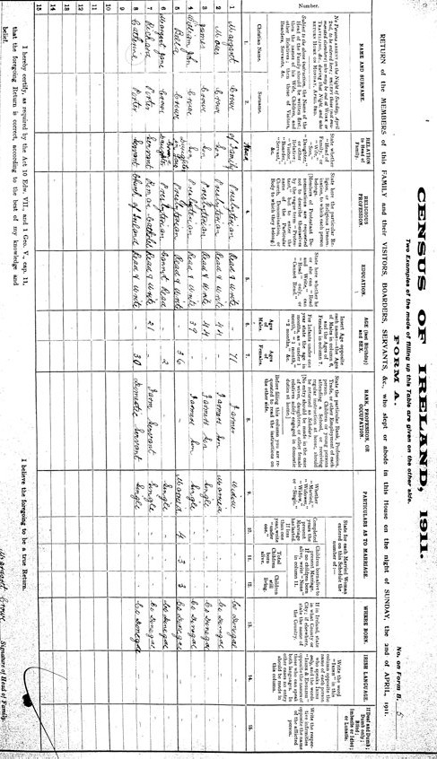
15
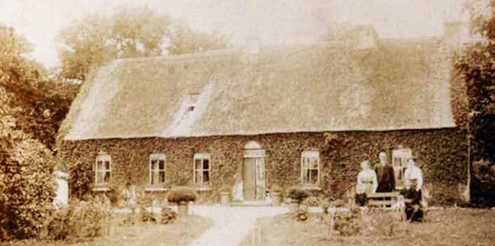
Step 4: The Tithe Applotment Books
This was an earlier land survey carried out between 1827 and 1835,
this time in order to see who should pay tithes (taxes) to the
Established Church, which was the Church of Ireland (Anglican).
It only shows Heads of Household in each townland and unfortunately,
it does not include all of them. Some land was excepted from paying
tithes. So you should not assume that simply because your ancestors
are not mentioned, they did not live here.
You should also be aware that the surveyors who drew up the Tithe
Applotment Books did not use the same type of acre as those who
drew up the Griffiths Valuation. This means that the plots of land held
by a family, from one survey to the next, are not directly comparable.
These records are available on microfilm at Letterkenny Central
Library, which is why it is included this early in the research. If you
cannot visit Letterkenny Library, an index of names in the Donegal Tithe
Applotment Books is available at your local Family History Centre
(British Film 919003):
http://tinyurl.com/3bgywk
and also the National Archives of Ireland in Dublin:
http://www.nationalarchives.ie/genealogy/valuation.html
Many parishes have also been transcribed to Lindel’s website:
http://freepages.genealogy.rootsweb.ancestry.com/~donegal/

16
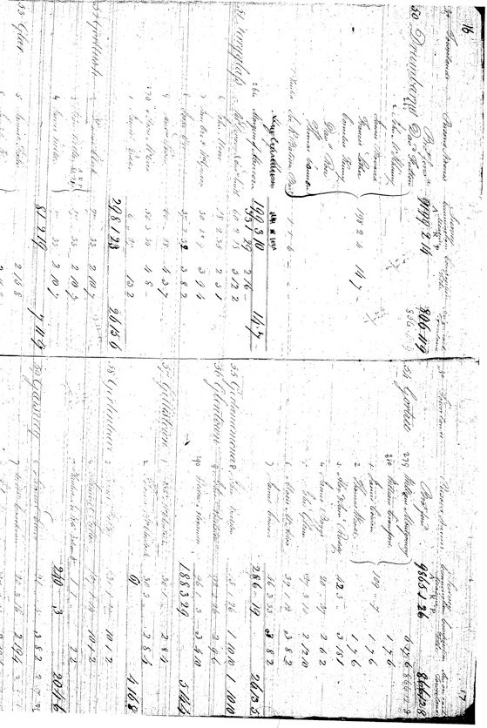
17
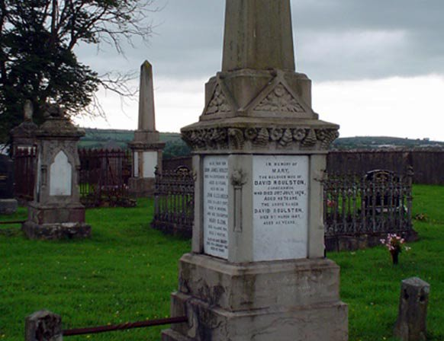
Step 5: Church Records of Births, Marriages and Deaths
These are usually available at local churches but most clergymen these
days are overworked and underpaid, so book in advance by phone; be
very polite; expect to have only restricted access in some cases by
those clergymen who consider the records to be very private,
notwithstanding the fact that you can photocopy any of them at the
Public Records Office in Belfast; and expect to contribute to the
“church roof fund”.
The only other source is PRONI in Belfast although some of the
Catholic records are held in the National Library of Ireland in Dublin:
http://www.nli.ie/en/parish-register.aspx
Most Presbyterian churches began keeping records circa 1830;
Roman Catholic churches usually even later; and Church of Ireland
churches perhaps a couple of decades earlier. A list of the records
available at churches or in Belfast or Dublin is given below. There may well be gaps however even after the starting dates given:
18
For ALL Protestant churches, not just Church of Ireland as suggested:
19
http://www.dun-na-ngall.com/churchoi.html
And for Catholic churches:
http://tinyurl.com/3gu67fd
Many church records are also now online (see page 21).

Early Church of Ireland registers often include Presbyterian and
Catholic baptismal and marriage records (and indeed, Methodist,
Baptist and the smaller denominations). This is because, in the first
half of the Nineteenth century, only the Church of Ireland was
permitted by law to register any baptisms, marriages or burials.
There are virtually NO death or burial registers (Church of Ireland
may be the exception) in Donegal; most registers will be baptisms
and about half of the churches will have a small number of
marriages. Some churches may also have Communicants Roll
Books and Vestry Minutes, both of which also have value to the family
historian.
Not all new parents bothered to baptise officially at the church so,
just because your folks are not there, does not mean they did not live
in this area.
Some registers will only give dates of baptism, especially the early
ones. Make sure you know whether you are recording a date of birth
or a date of baptism as the latter can be anything from a few days to
several years later than the former.
Church registers vary considerably in their value, depending on when
they were done (earlier ones are less detailed), which religion they
are and whether the clergyman was conscientious and neat in his
handwriting! Their main use to the family historian is for the names
of the fathers, and sometimes the mothers, of ancestors, as well as
their addresses. Catholic baptismal registers usually do not have the
parents but frequently have sponsors who may well be relations of
the child.
Most local churches will also have graveyards and some useful
information can be gathered from the headstones. Very few of these
will be much older than about 1850 and the older ones will usually
be in Church of Ireland graveyards. As with written records however,
many Church of Ireland graveyards will also have burials of people
belonging to other denominations.
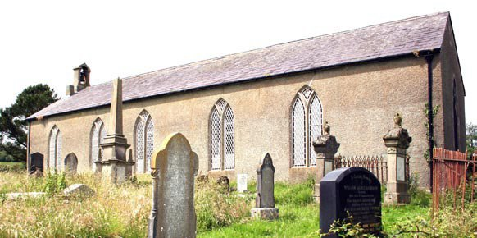
Step 6: Civil Records of Births, Marriages and Deaths
Civil registration of Births, Marriages and Deaths only began in 1864
(except for Protestant marriages which started in 1845). They end in
1933 for Family History Centres.
20
Indexes for all three (Births, Marriages and Deaths) and a limited set
of the actual records are available in the Family History Centre on the
Racecourse Road in Londonderry. At other Family History Centres,
you will have to order most of them from Salt Lake City. If you want to
be sure of ordering the correct films, the reference numbers can be
found at the LDS site:
http://www.tinyurl.com/5so2f
Copies of the actual birth, marriage and death certificates, from 1864 onwards (or 1845 for Protestant marriages), can be obtained from the Civil Registration Office in Letterkenny, Tel: (00353) 74 9124576.
You can order them over the telephone and pay by credit card. The cost is ten euros per certificate.
The records are also available at six euros per certificate from The General Registry Office in Roscommon:
http://www.groireland.ie

Especially in the years just after registration became compulsory,
many folks did not bother to comply with the law so yet again, missing
ancestors does not mean they did not exist.
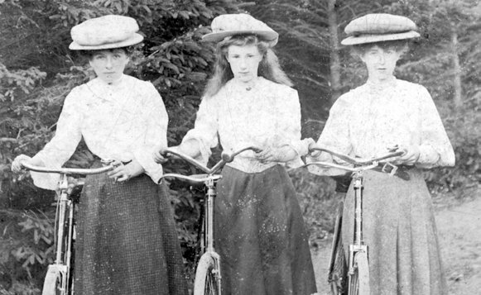
Births are useful for giving addresses, fathers’ names, mothers’
maiden names, and occasionally the person who registered the birth
will be a family member other than the father or mother.
Marriages are very useful for addresses, occupations, fathers’ names,
sometimes age, status (single or widowed), fathers’ occupations and
witnesses again may be relatives.
Deaths are mostly useful for determining approximate Dates of Births
by subtracting the age at death from the year of death. They also give
addresses, the person “Present at Death”, who is usually a very close
relative, and the cause of death.

The Mormons have now transcribed most of the indexes to the
records as well as many church and civil records and they can
be viewed online at:
https://familysearch.org/
A commercial website also has many church and civil records
of birth/baptism, marriage and death online at:
http://www.rootsireland.ie/
where the cost is €2.50 per record.
21
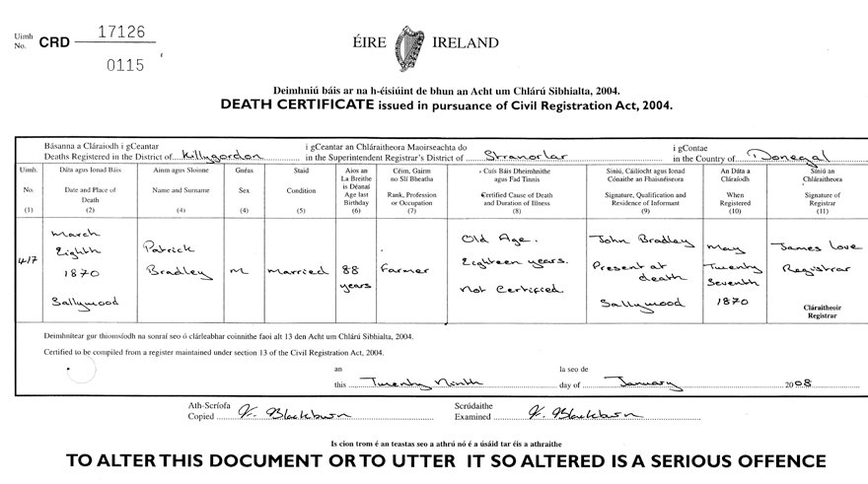
Step 7: Griffiths Valuation Revision Books
These are updates to the Griffiths Valuation and they show changes
to who held the property after the initial valuation in the 1850s up to
circa 1930.
They can be ordered from Family History Centres:
http://www.tinyurl.com/2sfcnc
They are also available in PRONI in Belfast and at the Valuation Office
in Dublin.
These records are very useful for showing younger family members
who only became Heads of Households after mid 1850s, or for
people who moved into the area after the Griffiths Valuation, or indeed
who may have left the area or died.
Dates are very unreliable as they were only recorded when an
enumerator noticed that the tenancy had changed. This means an
elderly person who went to live with a relative can disappear from the
books long before he or she died. Conversely, a deceased person may
be shown still in residence long after death!
These books are written up in 5 or 6 volumes, each covering ten to
fifteen years, and numbered back to front. For example, Book 5 will
cover the 1850s/60s, while Book 1 will contain the most recent
amendments.
The books are not easy to interpret on microfilm as coloured ink was
used to show the changes and the dates when the changes were
made. You will be reduced to comparing handwriting and the weight
of pen strokes!
23
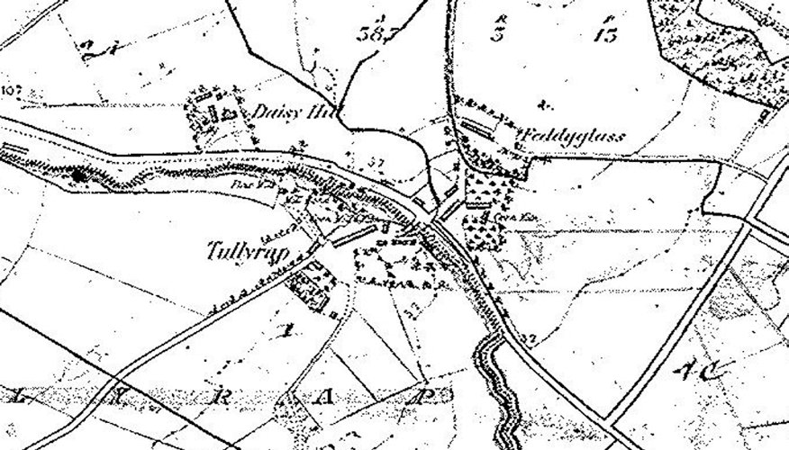
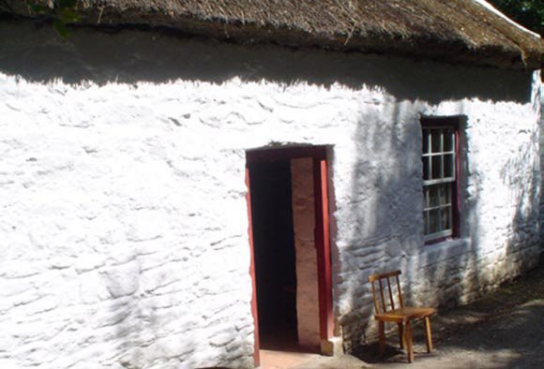
Step 8: House and Field Books
Precursors of the Griffiths Valuation, these were produced between
the late 1820s and the 1850s and were not usually published.
Like the Griffiths Valuation Revision Books, they show changes in
landholders and may therefore be the only source of someone who
emigrated before the Griffiths Valuation was published and Church or
Civil Records began.
The House Books, especially the rough drafts, are the most useful
as they list buildings whereas Field Books list land. Some do not list
houses worth less than £5.
Available at Family History Centres, PRONI in Belfast and at the
Valuation Office in Dublin.
Some of the original books are held by the Donegal County Archive
Service at the Three Rivers Centre in Lifford, Tel: (00353) 74
9172490. You should ring ahead to see what is available and to book
an appointment.
25
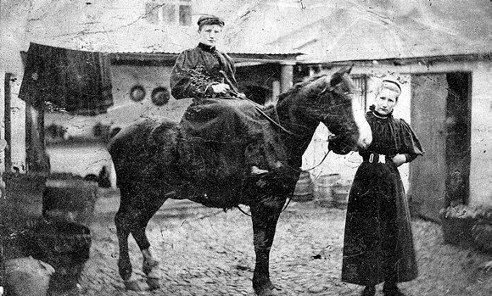
Step 9: Wills
Many Wills were destroyed in the fire at the Four Courts in Dublin.
Some do however remain in both the Public Records Office in Belfast
and the National Archives in Dublin. There are also indexes to many of
the older wills and from 1858 there are Calendars of Wills. These
contain brief transcripts of the wills and include the name and address
of the deceased person, where and when he or she died, the value
of the estate, the place of Probate and the name and address of the
person to whom probate was granted, including the relationship of that
person to the deceased, if there was one.
Remember that wills and Calendars of Wills will be catalogued by the
date of probate, not the date of death.
These Calendars of Wills, along with the wills themselves from 1900,
are held in the Probate Office in Bishop Street in Derry, Tel: (0044)
028 7136 3448. Telephone in advance as a ladder may be needed!

The calendars and the wills are also available at the Public Record
Office in Belfast and the calendars and many of the wills can now be viewed online at the PRONI website:
http://tinyurl.com/c4zqrm4
26
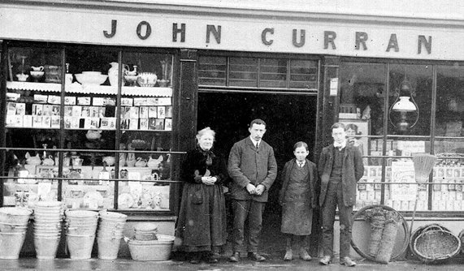
Step 10: Old Age Pension/Census Returns
27
In 1909 the Old Age Pension was introduced in Ireland but elderly
people had to prove that they were over 70 in order to claim it. Since
birth certificates had not been introduced until 1864, this in effect
meant applying to the authorities in Dublin, who held the 1841 and
1851 censuses, and asking if your name was recorded therein. These
letters of application survived after the two censuses were destroyed
and are our only record of what was in them. They can prove of
immense value in locating your ancestors.
The letters are stored in large binders in the Public Records Office
in Belfast. They were filmed by the Church of Latter Day Saints and
so are available through your local Family History Centre. The only
problem is that the letters are not very well catalogued and Donegal
applications will be found in several volumes mixed in with other
counties. It is a matter of trawling through the volumes in Belfast, or
the microfilms in your FHC:
http://www.tinyurl.com/2jevf2
Remember, this guide only covers the relatively straightforward
sources. When you have done all of this it will be time to tackle the
really serious business of Estate Papers and Land Registry Deeds!
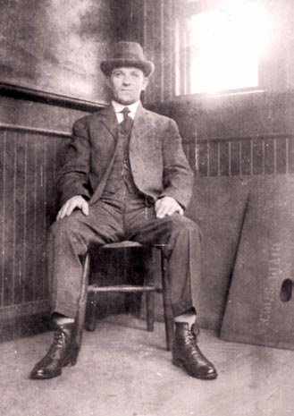
Triangulating
If you do not know the townland where your ancestors lived, the best
way to make progress is to try to locate your ancestors using the
confluence of two or more surnames. Most poor folks in the
Nineteenth Century, and even many wealthier ones, did not travel far to
marry and therefore they should generally be found living close to each
other.
You need to check the Griffiths Valuation for all of the names you have
and see which parish or group or townlands contains all or most of the
surnames you are researching. This works better if you are using at
least one unusual name. Most importantly, it can be done online in advance of any visit using the indexes to the Griffiths Valuation given on Page 8 above and the map website mentioned on page 11.

Tommy Gordon, Manhattan

28
Hints and Tips
Record every detail of relevant records. If possible, use a good digital
camera so that you can examine the records again and again in the
light of further evidence. Most Family History Centres will allow this but
not all public records offices or churches are so amenable.
Organise your raw material, even if only into Land Records, Birth,
Marriage and Deaths Records, and Other Records, so that you can
easily locate data at a later date.
Visit the Lists for Donegal where people will help with your research: http://lists.rootsweb.ancestry.com/index/intl/IRL/DONEGALEIRE.html
and
http://lists.rootsweb.ancestry.com/index/intl/IRL/IRL-CO-DONEGAL.html

Use a Family Tree Programme to create diagrams, which act as both
repositories of the data you have collected and also representations of
the familial links between your ancestors. Family Tree Maker is best
for reports but GenoPro is best by far for trees (and the trial version is
free). Both store data efficiently.
http://www.genopro.com and http://www.familytreemaker.com
29
Whether you use a tree or some other system, it is essential that you
note down the source of every piece of information you find. You will
always need to know where you found a date, fact, person or event if
you want to determine how reliable that information is in the light of
contradictory evidence which you may find as your research
progresses. Remember those people who had managed to lose 10 or
more years off their age for the 1901 census. A church birth record
will be a much more reliable guide to the true date of birth!
And finally, do have fun. Genealogy is only a hobby, even if an
addictive one!
And enjoy Donegal and all it has to offer.
Useful Addresses
30
Central Library
Oliver Plunkett Road
Letterkenny
Co Donegal
Tel: +353 74 9124950
Civil Registration Office
Tirconnell House
St Conals Hospital
Letterkenny
Co. Donegal
Tel: +353 74 9124576
The Archive Service
Donegal County Council
Three Rivers Centre
Lifford
Co. Donegal
Tel: +353 74 9172490
Family History Centre
Church of Jesus Christ of Latter Day Saints
Racecourse Road
Londonderry
BT48 7RE
Tel: +44 48 7135 0179
Probate Office
Courthouse
Bishop Street
Londonderry
BT48 6PY
Tel: +4448 7136 3448
31

Travelling to Donegal
Donegal Airport,
City of Derry Airport
http://www.cityofderryairport.com
Belfast City Airport
http://www.belfastcityairport.com
C.I.E , Irish Rail and Bus Network
http://www.cie.ie

Visit:
Monreagh Heritage Centre
http://monreaghulsterscotscentre.town.ie/
Letterkenny Museum
http://www.heritageisland.com/attractions/donegal-county-museum/
Doagh Famine Village
http://www.doaghfaminevillage.com/

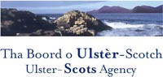
Written by Boyd Gray, Email: boydgray26@utvinternet.com
Website: http://westulstergenealogy.com/

